SOFTWARE TESTING WITH SELENIUM

DAY-5

**Task1**

**package** day5;

**import** org.openqa.selenium.By;

**import** org.openqa.selenium.WebDriver;

**import** org.openqa.selenium.WebElement;

**import** org.openqa.selenium.chrome.ChromeDriver;

**import** org.openqa.selenium.chrome.ChromeOptions;

**import** org.openqa.selenium.interactions.Actions;

**import** io.github.bonigarcia.wdm.WebDriverManager;

**public** **class** taskQ1{

**public** **static** **void** main(String[] args) {

// **TODO** Auto-generated method stub

WebDriverManager.*chromedriver*().setup();

System.*setProperty*("webdriver.chrome.driver","C:\\drivers\\chromedriver.exe");

ChromeOptions co=**new** ChromeOptions();

co.addArguments("--remote-allow-origins=*");

WebDriver driver=**new** ChromeDriver(co);

driver.get("https://demoqa.com/droppable/");

Actions a=**new** Actions(driver);

WebElement source_ele=driver.findElement(By.*id*("draggable"));

WebElement dest_ele=driver.findElement(By.*id*("dropable"));

a.clickAndHold(source_ele).release(dest_ele).build().perform();

a.dragAndDrop(source_ele, dest_ele).build().perform();

}

}

Output:

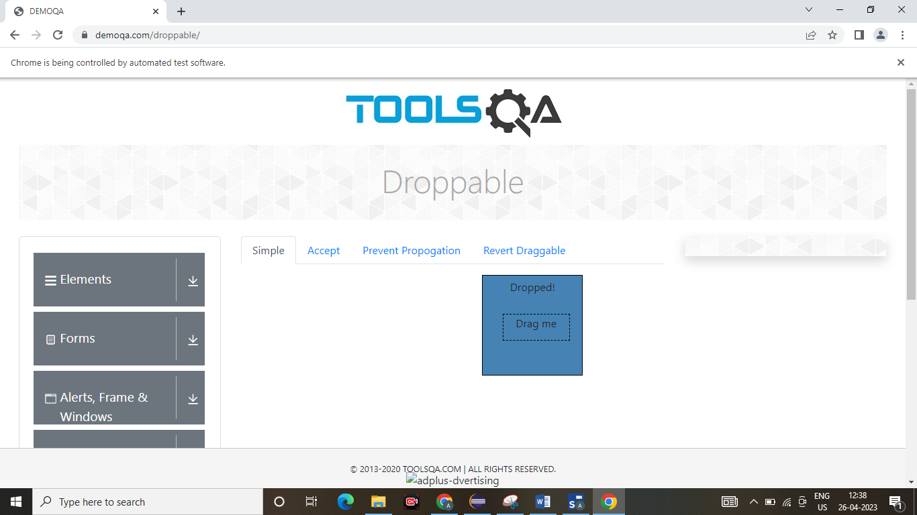

**TASK2:**

**package** day5;

**import** org.openqa.selenium.By;

**import** org.openqa.selenium.WebDriver;

**import** org.openqa.selenium.WebElement;

**import** org.openqa.selenium.chrome.ChromeDriver;

**import** org.openqa.selenium.chrome.ChromeOptions;

**import** org.openqa.selenium.interactions.Actions;

**import** io.github.bonigarcia.wdm.WebDriverManager;

**public** **class** taskQ2{

**public** **static** **void** main(String[] args) {

// **TODO** Auto-generated method stub

WebDriverManager.*chromedriver*().setup();

System.*setProperty*("webdriver.chrome.driver","C:\\drivers\\chromedriver.exe");

ChromeOptions co=**new** ChromeOptions();

co.addArguments("--remote-allow-origins=*");

WebDriver driver=**new** ChromeDriver(co);

driver.get("https://jqueryui.com/droppable/");

driver.switchTo().frame(0);

Actions a=**new** Actions(driver);

WebElement source_ele=driver.findElement(By.*id*("draggable"));

WebElement dest_ele=driver.findElement(By.*id*("droppable"));

a.clickAndHold(source_ele).release(dest_ele).build().perform();

a.dragAndDrop(source_ele, dest_ele).build().perform();

}

}

Output:

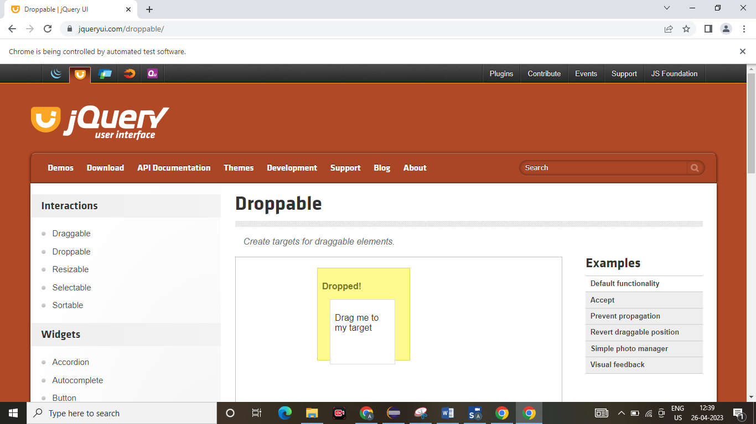

**TASK3**

**package** day5;

**import** org.openqa.selenium.Alert;

**import** org.openqa.selenium.By;

**import** org.openqa.selenium.WebDriver;

**import** org.openqa.selenium.WebElement;

**import** org.openqa.selenium.chrome.ChromeDriver;

**import** org.openqa.selenium.chrome.ChromeOptions;

**import** io.github.bonigarcia.wdm.WebDriverManager;

**public** **class** taskQ3{

**public** **static** **void** main(String[] args) {

// **TODO** Auto-generated method stub

WebDriverManager.*chromedriver*().setup();

System.*setProperty*("webdriver.chrome.driver","C:\\drivers\\chromedriver.exe");

ChromeOptions co=**new** ChromeOptions();

co.addArguments("--remote-allow-origins=*");

WebDriver driver=**new** ChromeDriver(co);

driver.get("https://demo.guru99.com/test/delete_customer.php");

WebElement txt_box=driver.findElement(By.*name*("cusid"));

WebElement submit_btn=driver.findElement(By.*name*("submit"));

txt_box.sendKeys("401");

submit_btn.click();

Alert alert1=driver.switchTo().alert();

alert1.dismiss();

txt_box.clear();

txt_box.sendKeys("402");

submit_btn.click();

Alert alert2=driver.switchTo().alert();

alert2.accept();

Alert alert3=driver.switchTo().alert();

String txt=alert3.getText();

alert3.accept();

}

}

OUTPUT:

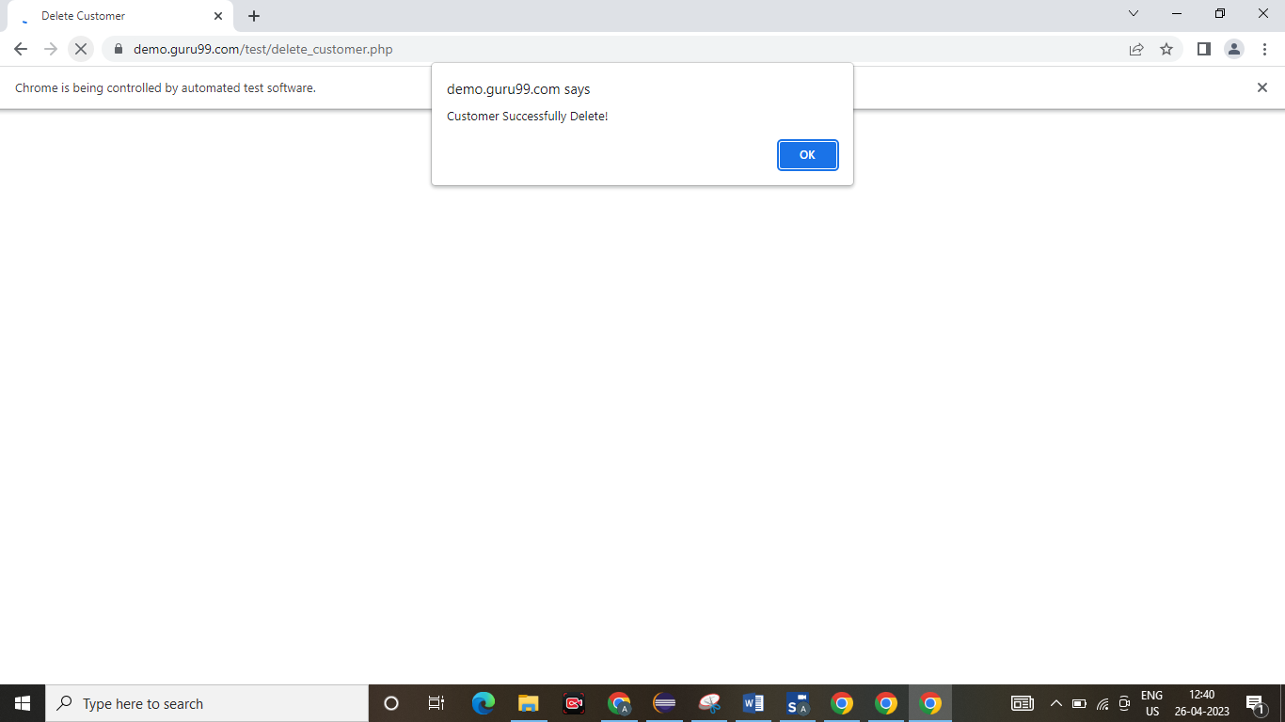

TASK4

package day5;

import org.openqa.selenium.By;

import org.openqa.selenium.JavascriptExecutor;

import org.openqa.selenium.Keys;

import org.openqa.selenium.WebDriver;

import org.openqa.selenium.WebElement;

import org.openqa.selenium.chrome.ChromeDriver;

import org.openqa.selenium.chrome.ChromeOptions;

public class d55 {

public static void main(String[] args) throws InterruptedException

{

System.setProperty("webdriver.chrome.driver","C:\\ChromeDriver\\chromedriver.exe");

ChromeOptions co= new ChromeOptions();

co.addArguments("--remote-allow-origins=*");

WebDriver driver= new ChromeDriver(co);

driver.get("https://WWW.abhibus.com/bus-ticket-booking");

WebElement leaving_from = driver.findElement(By.xpath("//*[@id=\"source\"]"));

// leaving_from.sendKeys("chennai");

leaving_from.sendKeys("Chennai");

Thread.sleep(3000);

leaving_from.sendKeys(Keys.ENTER);

WebElement going_to = driver.findElement(By.xpath("//*[@id=\"destination\"]"));

// going_to.sendKeys("coimbatore");

going_to.sendKeys("Coimbatore");

Thread.sleep(3000);

going_to.sendKeys(Keys.ENTER);

WebElement datepicker = driver.findElement(By.xpath("//*[@id=\"datepicker1\"]"));

datepicker.click();

JavascriptExecutor js= (JavascriptExecutor) driver;

js.executeScript("arguments[0].setAttribute('value','02-05-2023')",datepicker);

WebElement search_btn = driver.findElement(By.xpath("//*[@id=\"seo_search_btn\"]"));

search_btn.click();

}

}

Output:

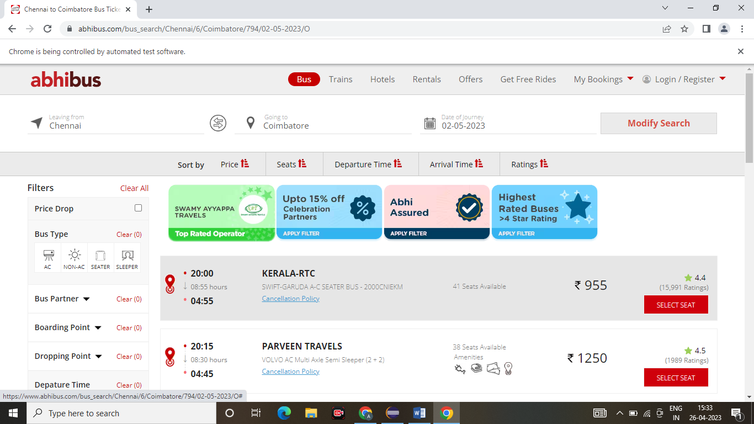

Task 05: